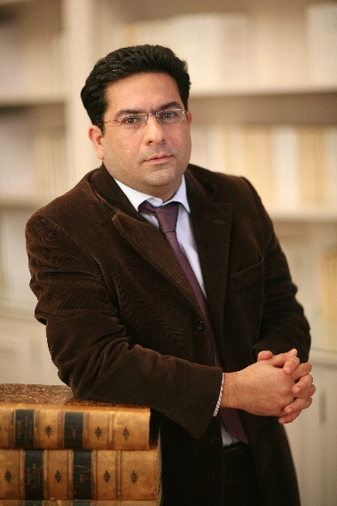
Dr. Hamid Gharavi
Founding Partner of Derains & Gharavi International
Dr. Hamid Gharavi, co-founding Partner of the Paris-based arbitration firm Derains & Gharavi International, is a member of the Paris & New York Bars.
A French-Iranian national, Dr. Hamid Gharavi has acted as Chairman, Sole arbitrator, co-arbitrator or counsel in over 150 commercial ad hoc and institutional arbitrations, including over 30 investment arbitrations under foreign investment laws and bilateral and multilateral treaties, in relation to a broad spectrum of industries, ranging from oil and gas, mining, M&A, military ordnance and defense, telecommunications, media, and aviation, to agency, distribution, sales, construction, poultry, duty free, hospitality, real estate, wood and derived products, pharmaceutical, and sports, as well as investments in general involving all continents and over 50 countries, including many Asian States.
Dr. Gharavi has been appointed to the Panel of ICSID Arbitrators by the Kingdom of Cambodia, as one of the four Court Members of the International Istanbul Arbitration Centre (as of 2015), as Court member of the London Court of International Arbitration (from 2008-2012), the Commission on Arbitration of the ICC, as well as arbitrator panels of the KLRCA, SIAC, TRAC, DIAC and Court of Arbitration for Sport.
Dr. Gharavi teaches investment arbitration in graduate studies at University of Paris II Panthéon-Assas. He is the author of a book entitled “The International Effectiveness of the Annulment of an Arbitral Award,” published by Kluwer Law International and publications in all the main arbitration law reviews, and a regular speaker at international conferences.
Dr. Gharavi holds a PhD from the University of Paris II, and post-graduate degrees from New York University School of Law and University of Paris I Panthéon-Sorbonne.
Before founding Derains & Gharavi International, Dr. Gharavi was a partner at Salans in Paris after having started his career at Skadden Arps Slate Meagher & Flom LLP in New York and as Visiting Professor at the University of Richmond School of Law.
Dr. Gharavi’s full CV is available at http://www.derainsgharavi.com/lawyers/hamid-gharavi/.

